

DXC REAL TIME PROJECTS

AZ-900, DP - 203





**Name:** Nandipati Lakshmi Sunitha

**Reg No:** DXC262AB12023

**Project1 Name: Smart Vehicles Date:** 10-06-2022

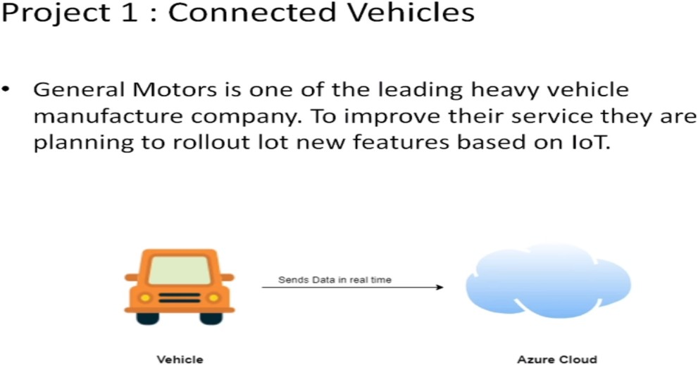

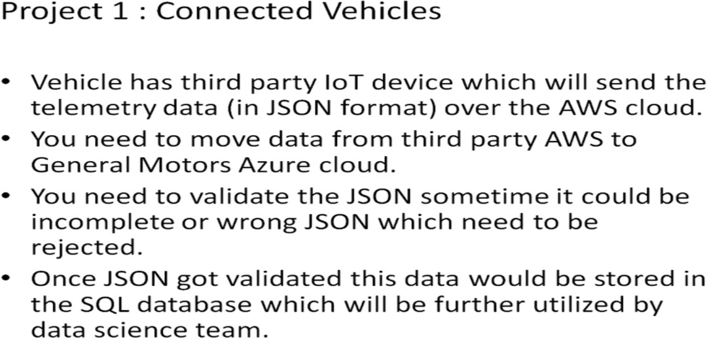

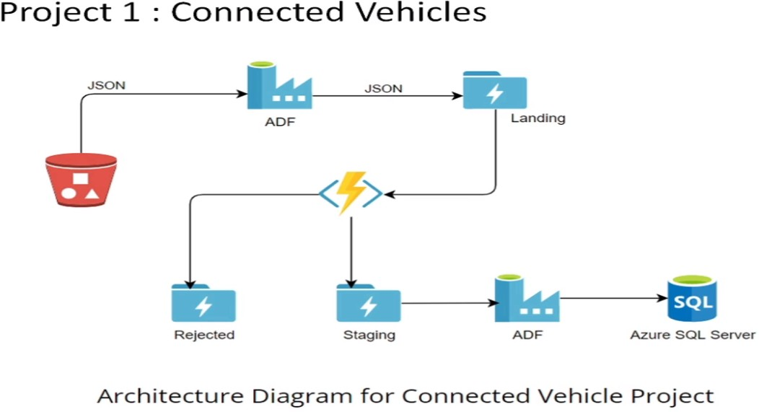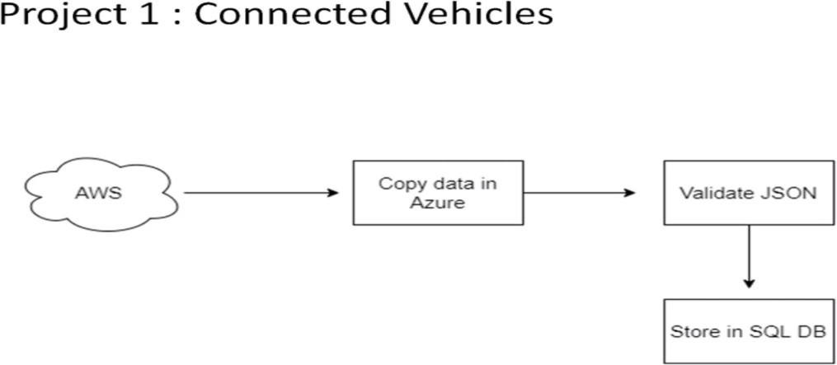

**Practical Lab:** Create **Azure Data Factory** Account For Data pipelines

**Step 1:** Login into “**Microsoft Azure Portal**” and search for “**Data Factories**”.

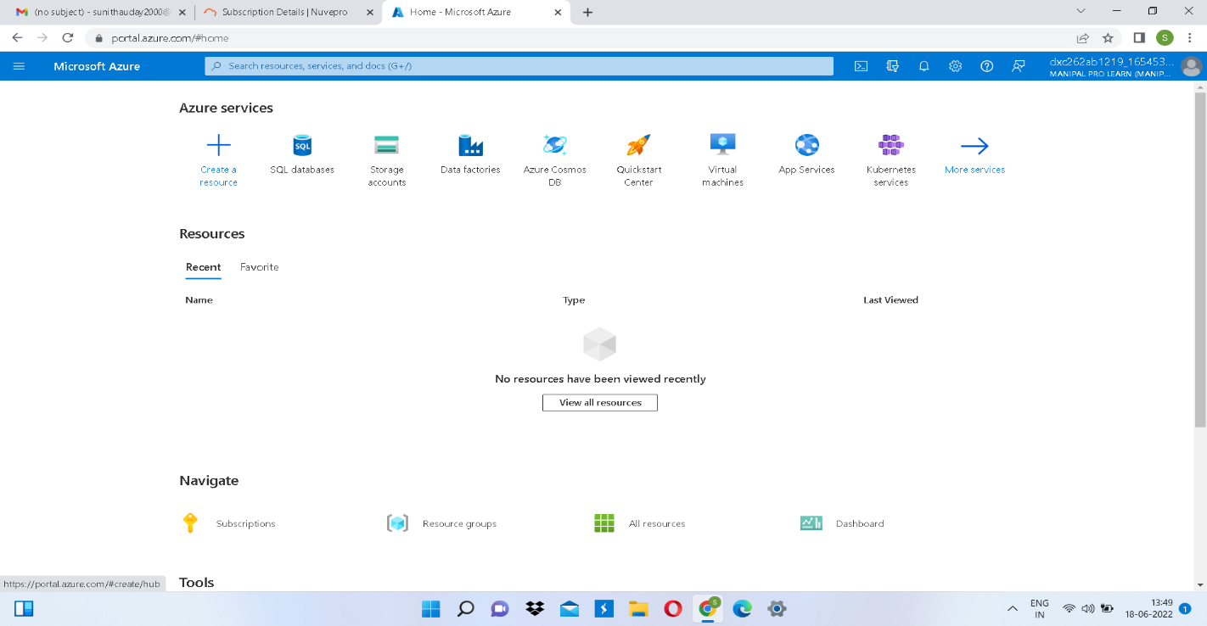

**Step 2:** Now click on “**Data Factories**” and then on “**+create**” to create a Azure Data Factory.

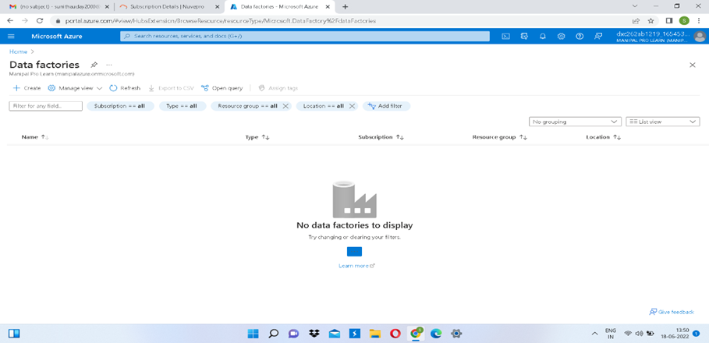

**Step 3:** Now will the required fields.

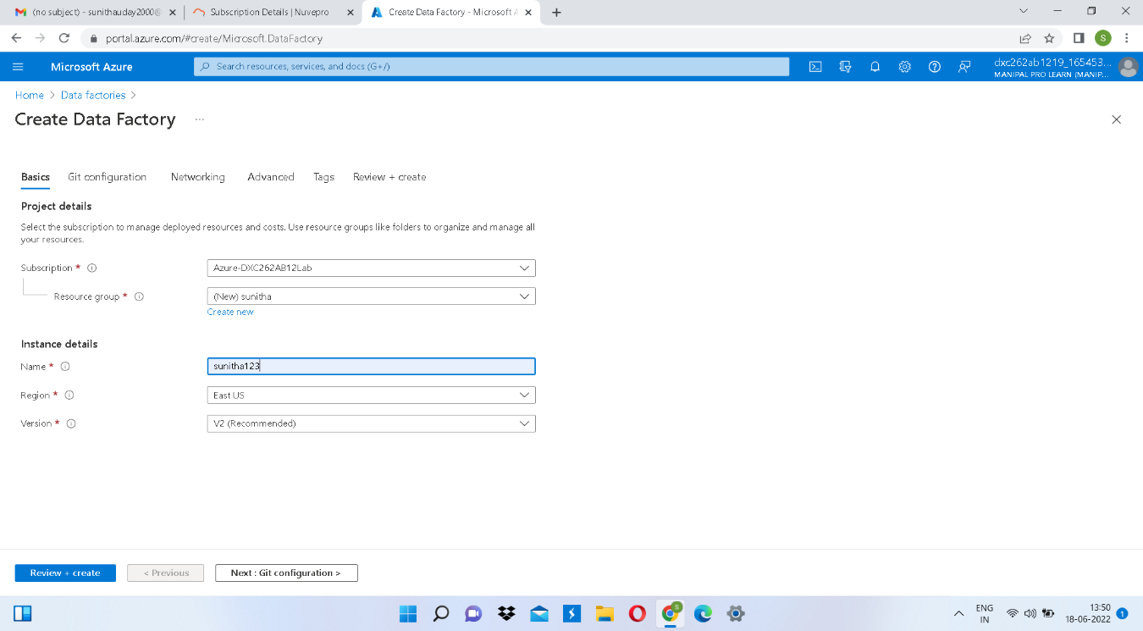

**Step 4:** After filling the required fields click on “Review + create” to validate the field.

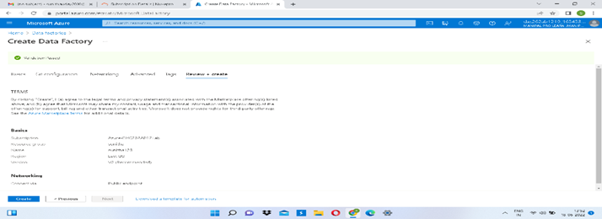

**Step 5:** Now click on “create” at the left bottom to deploy the Data Factory.

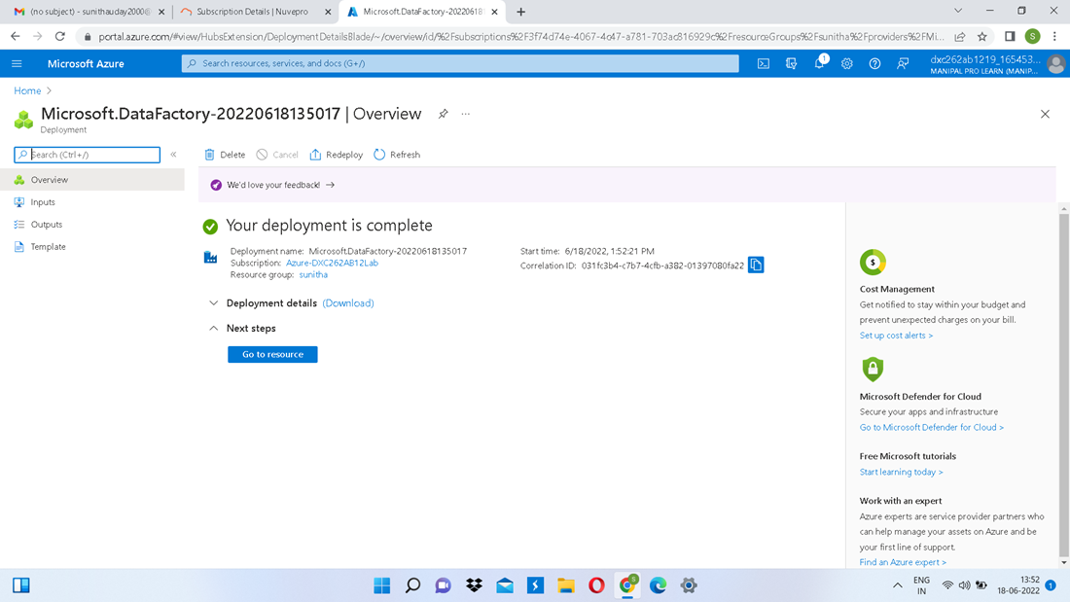

**Step 6:** Deployment is completed.

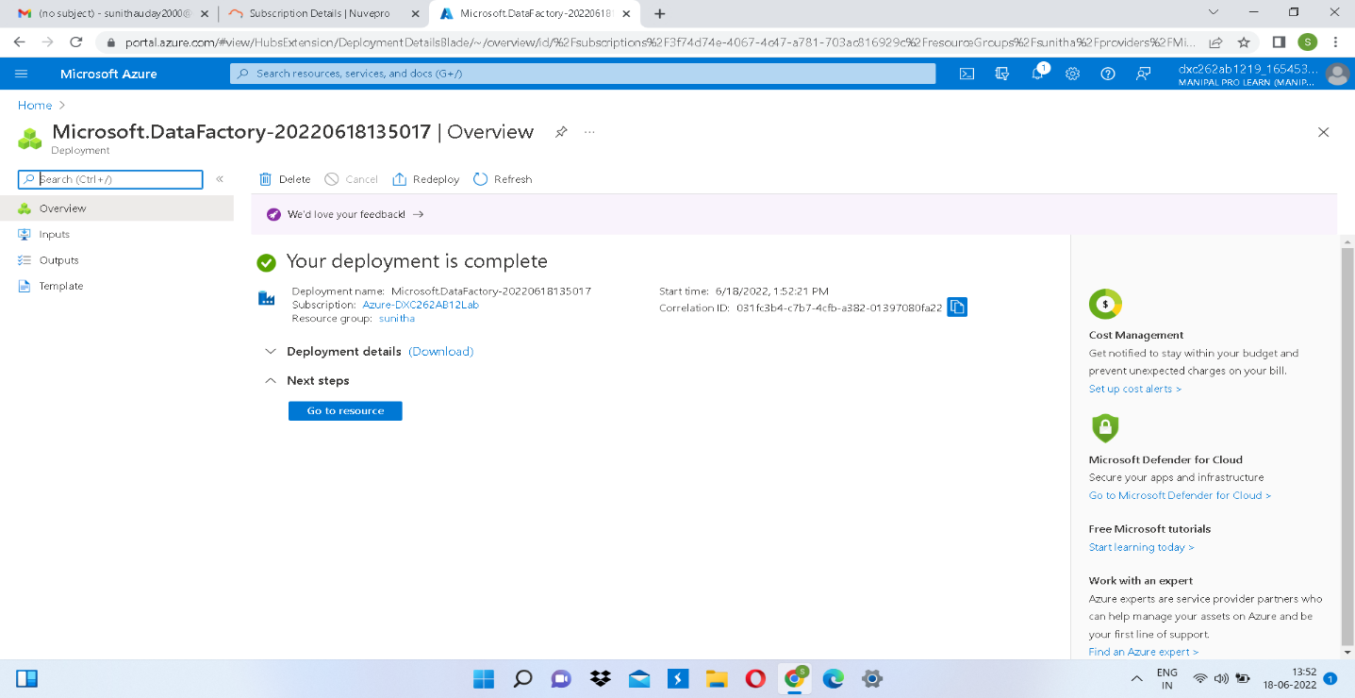

**Step 7:** Now click on “Go to Resource” and then open Azure Data Factory Studio.

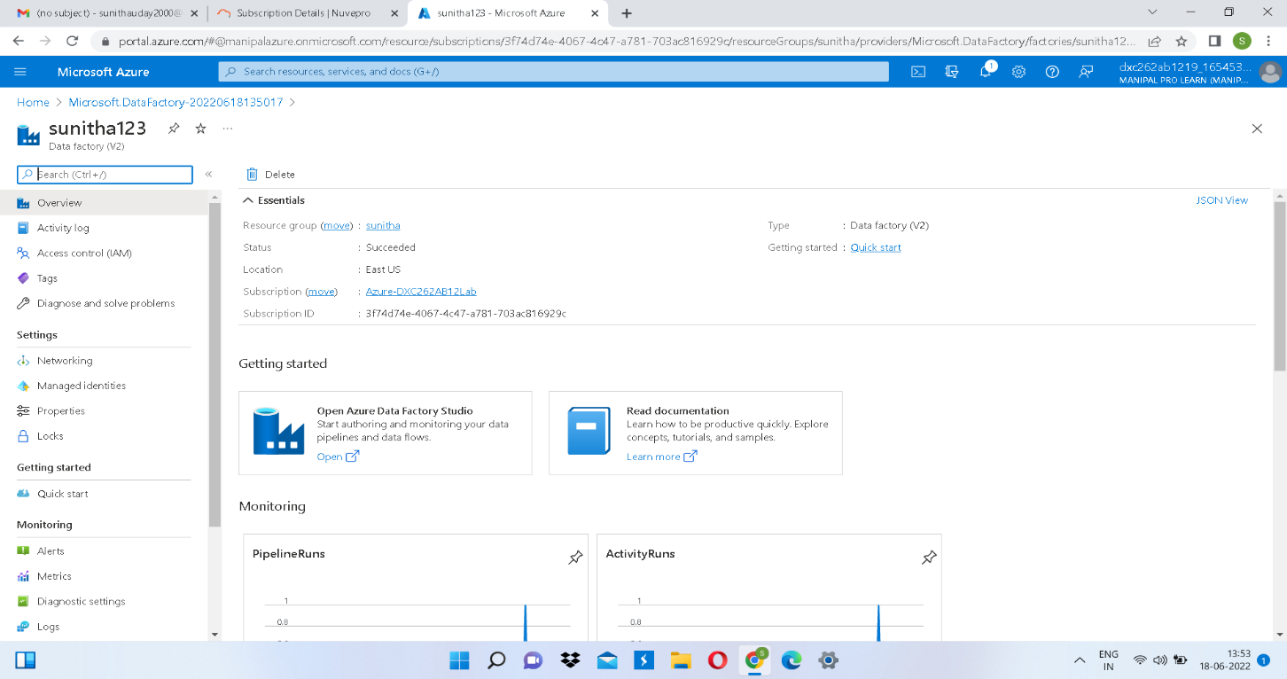

**Step 8:** Creation of “Azure Data Factory” is done.

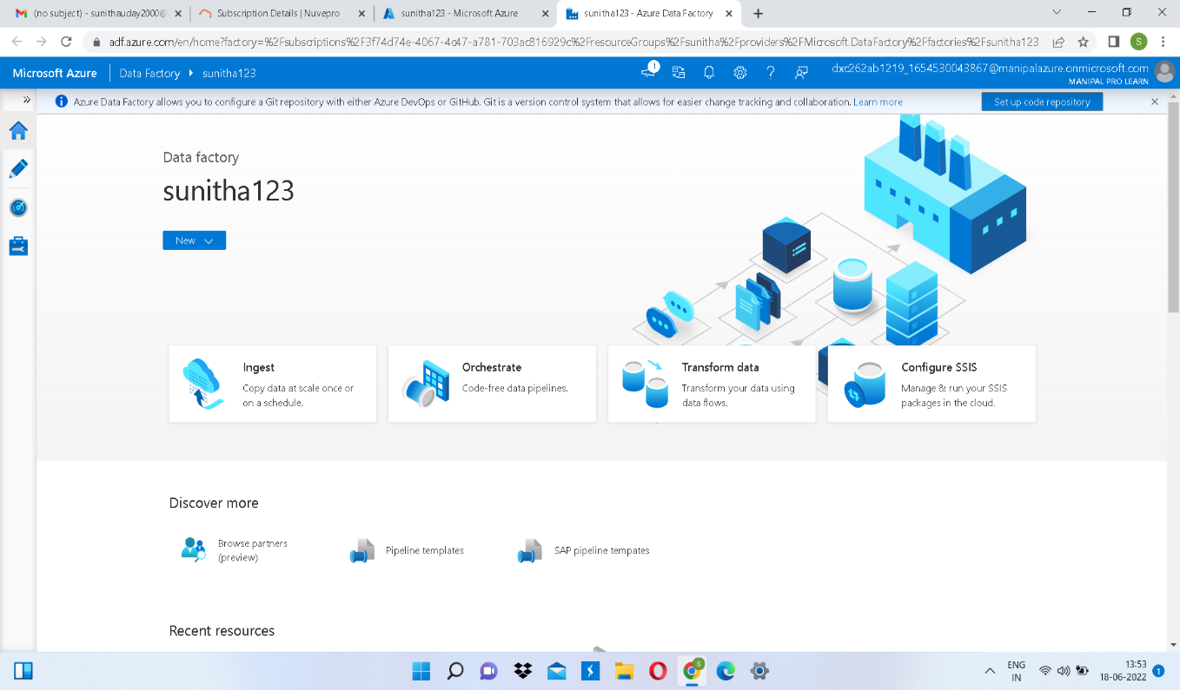

**Practical Lab:** Create **ADF Pipeline** End to end pipeline with triggers enabled.

**Step 1:** To create a pipeline first you need to create a storage account. For that search for storage accounts in azure portal.

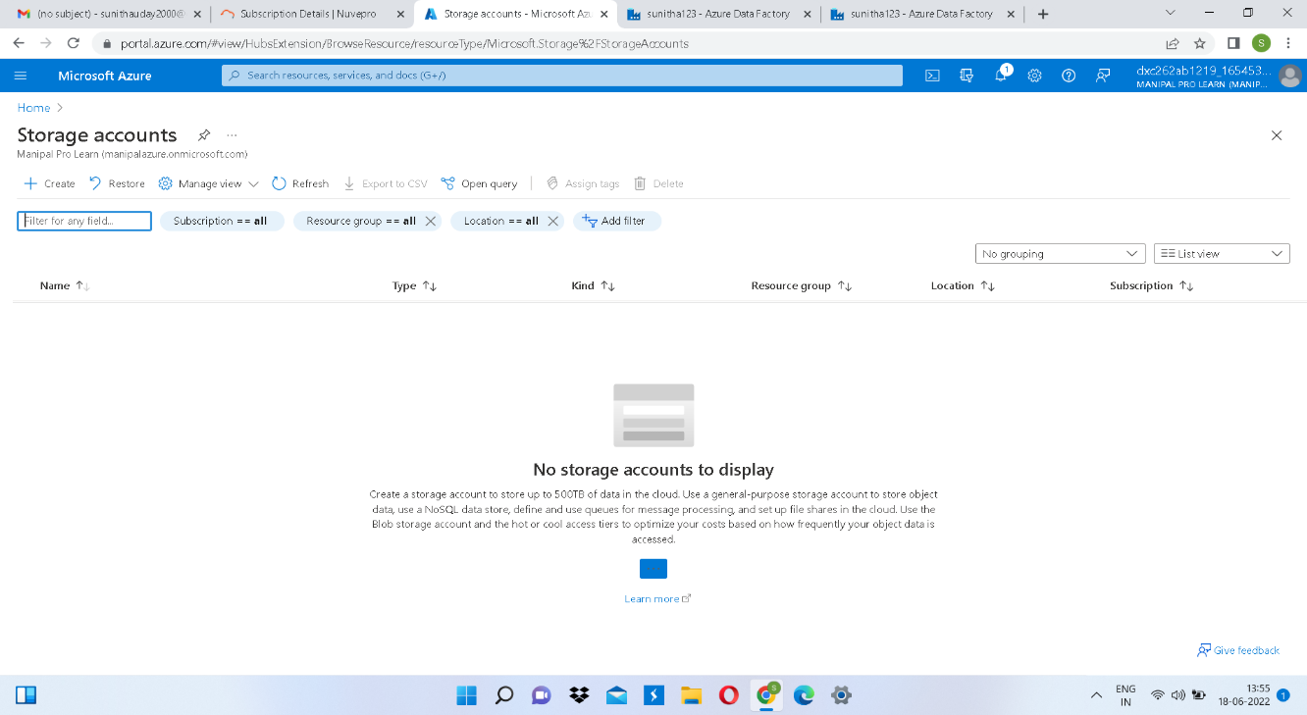

**Step 2:** Open Storage accounts and click on “+create”.

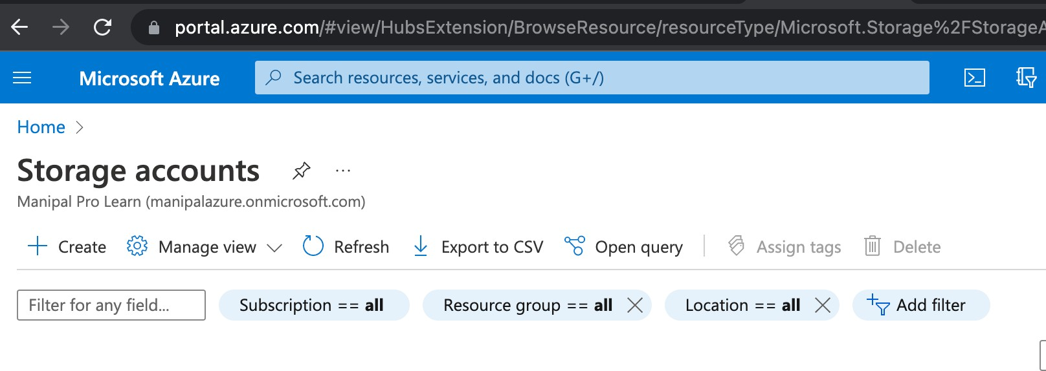

**Step 3:** Now fill all the required fields.

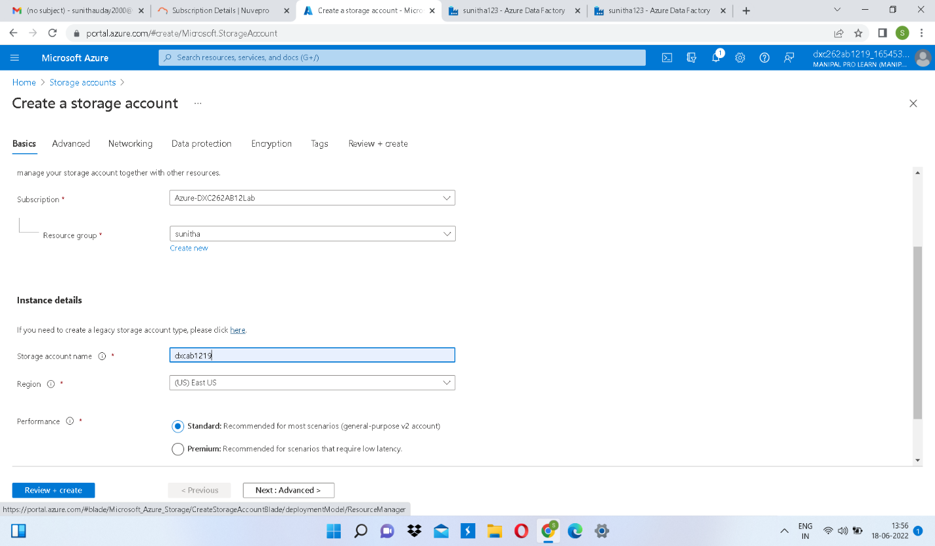

**Step 4:** After filling the required fields click on “Review + create” to validate the fields.

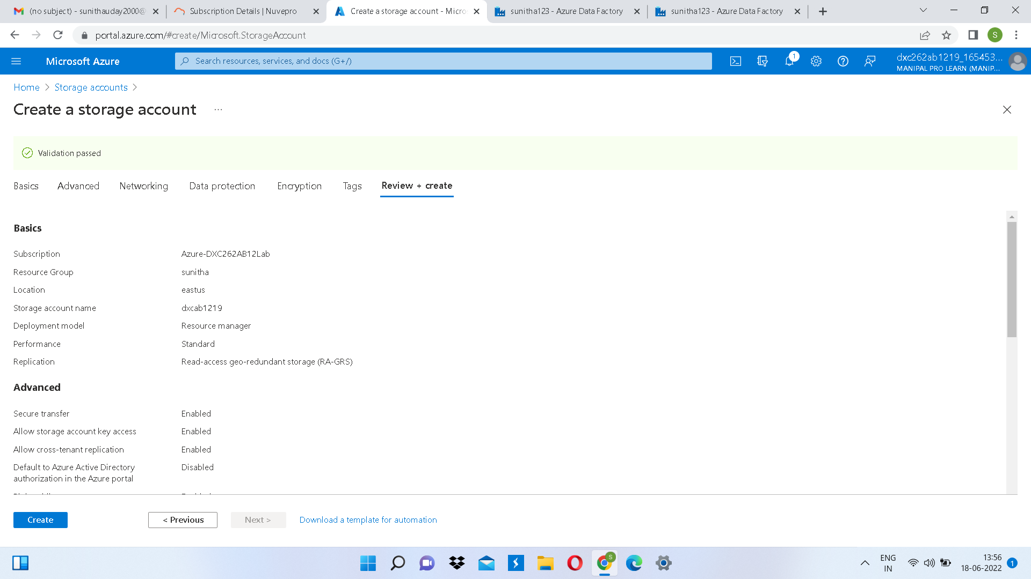

**Step 5:** Now click on “create” to deploy the storage account.

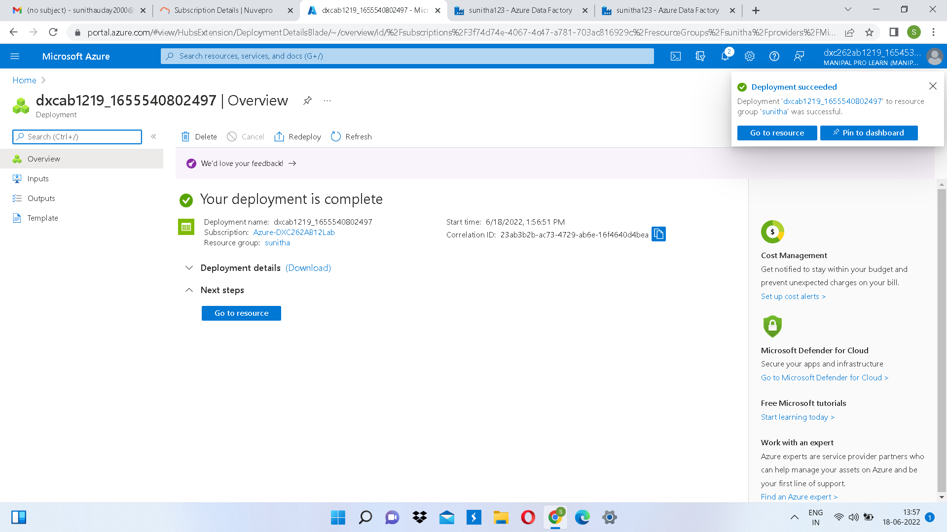

**Step 6:** Now click on “Go to Resource” and create 2 new containers one for source and the other for destination.

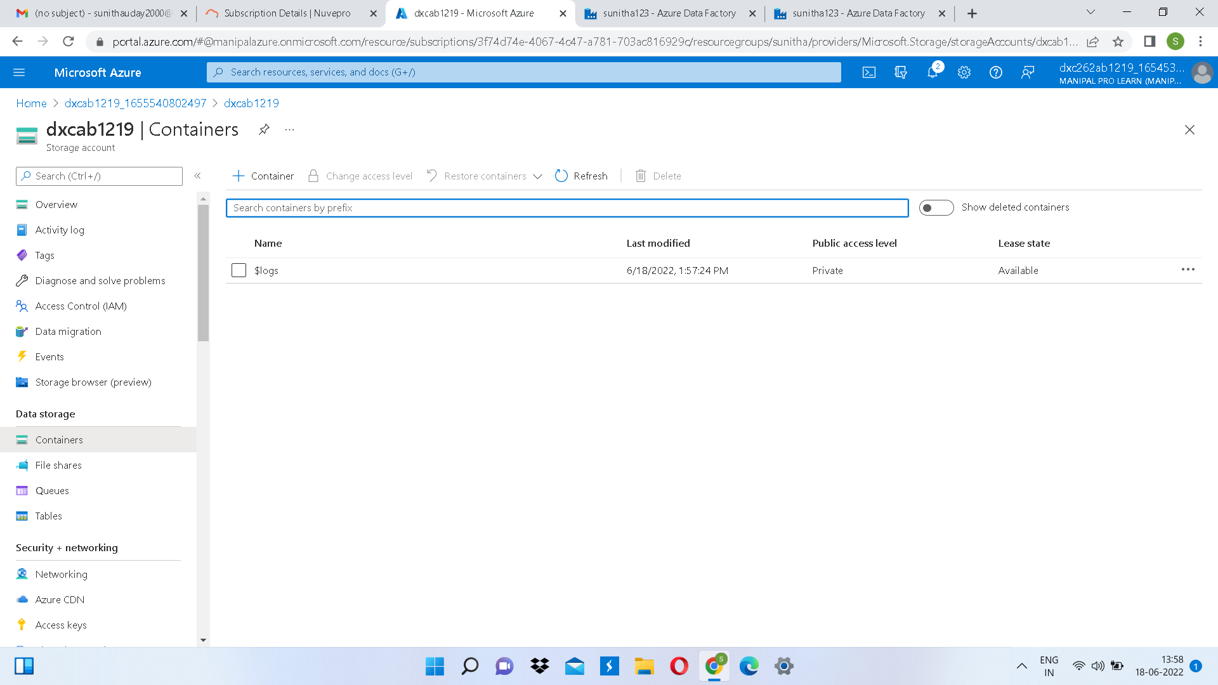

**Step 7:** Fill the required fields and click on create.

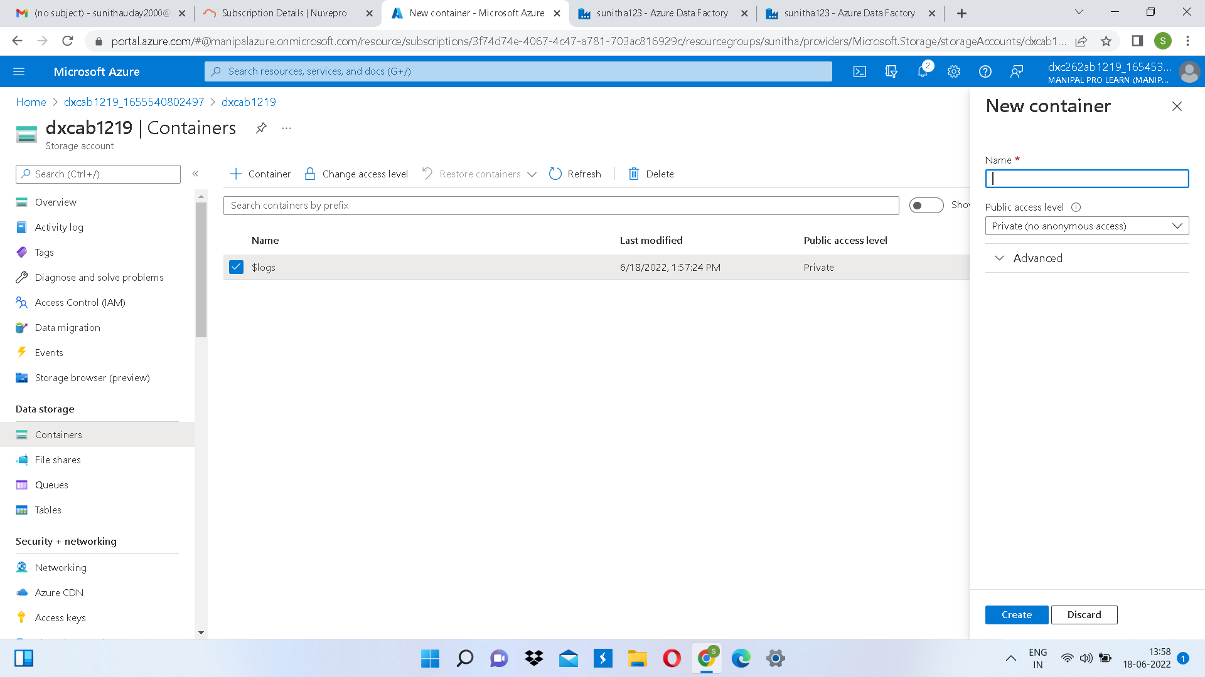

Source Storage container has been created.

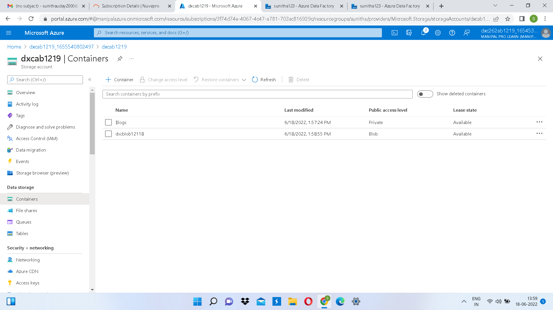

**Step 8:** Now create a container for the destination container.

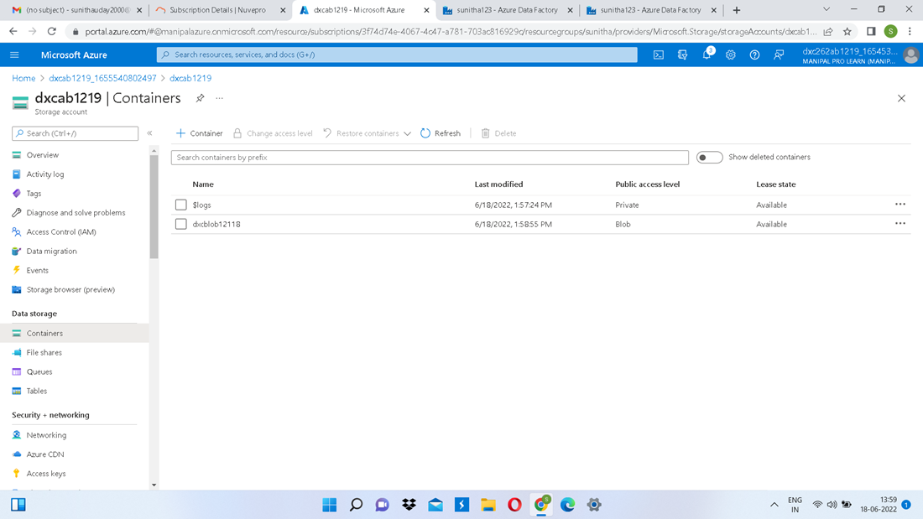

**Step 9:** Now to create a pipeline click “ingest” in the data factory.

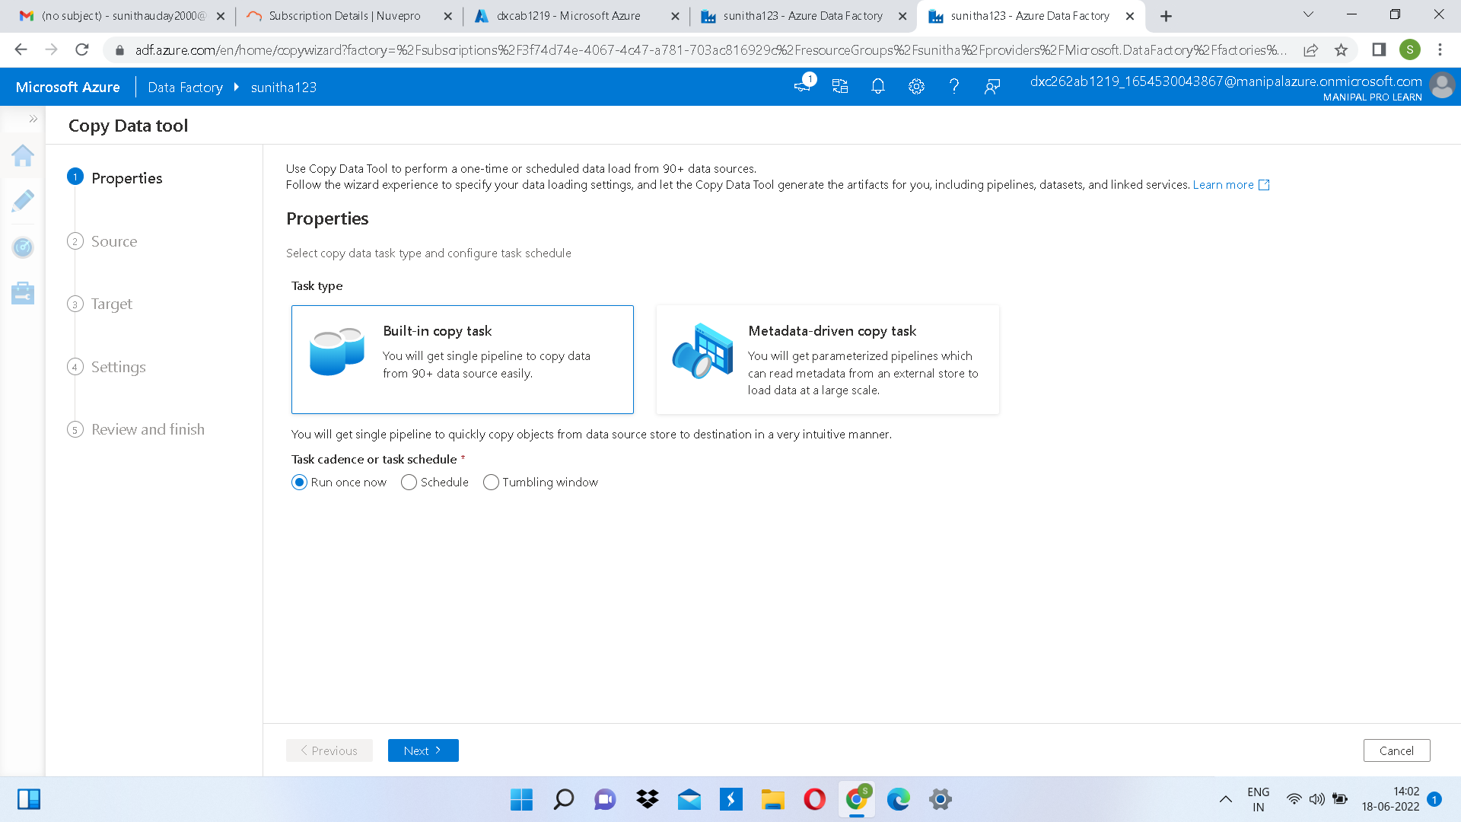

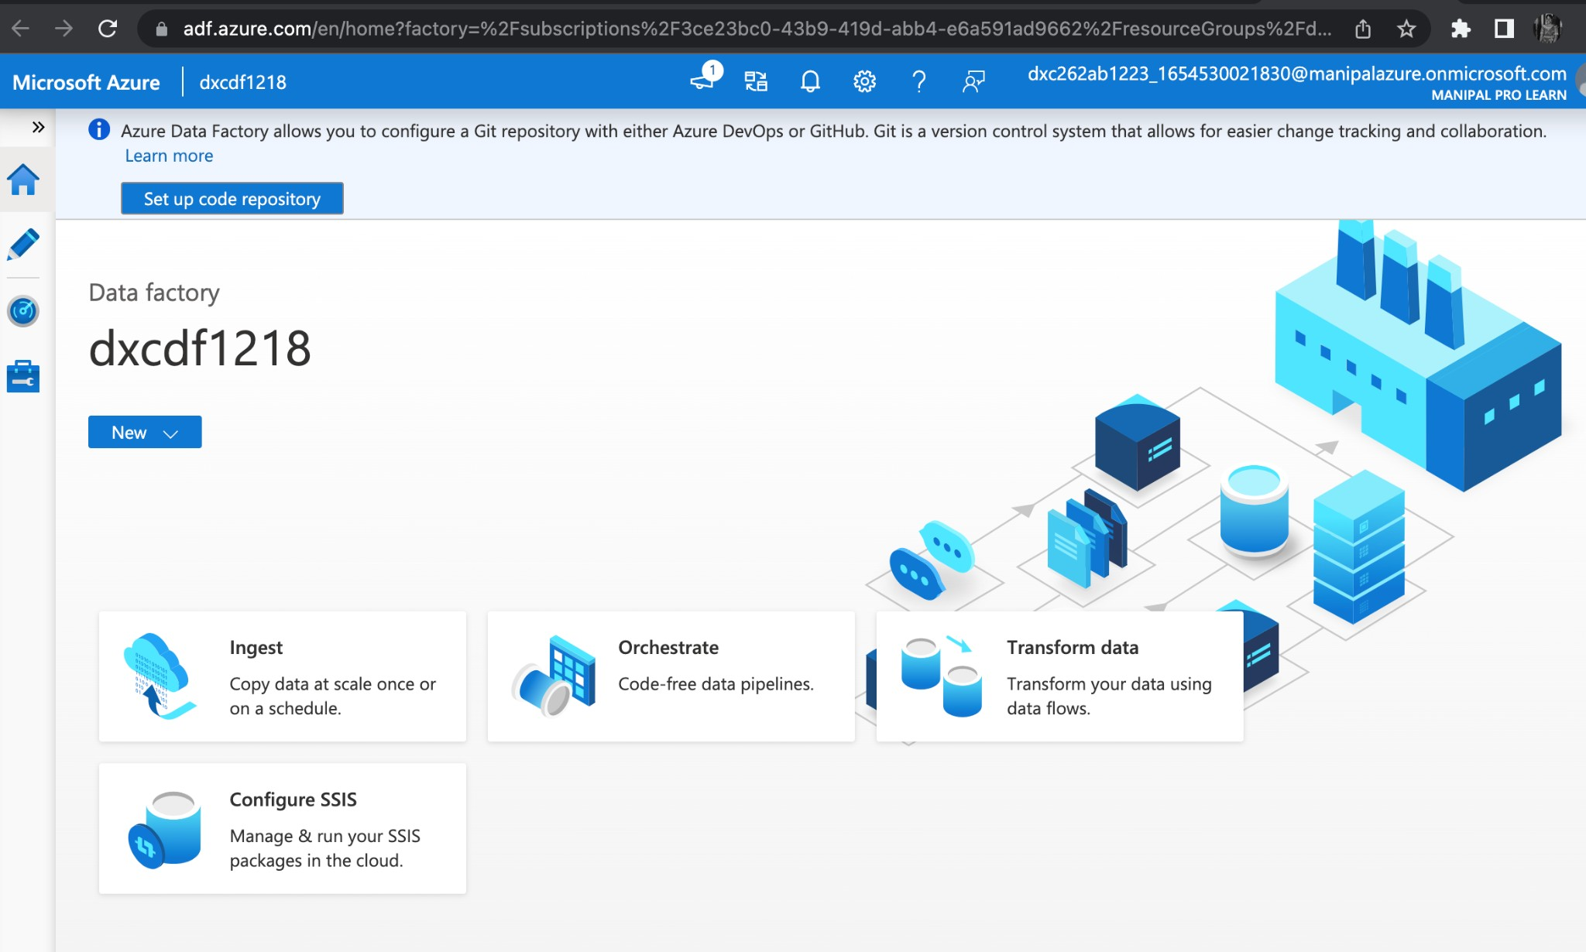

**Step 10:** Now schedule the pipeline.

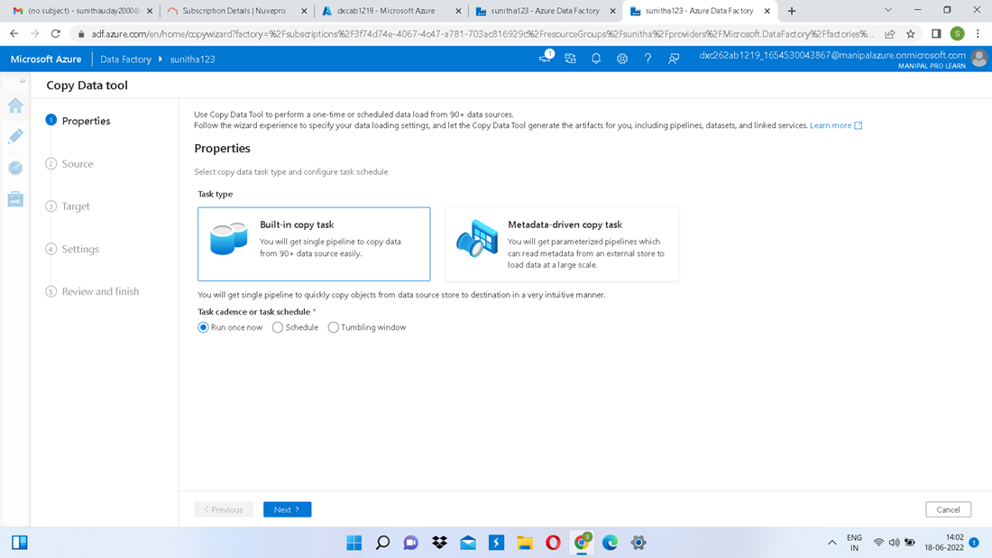

After filling the required fields in the copy data tool review the fields and create the pipeline and trigger.

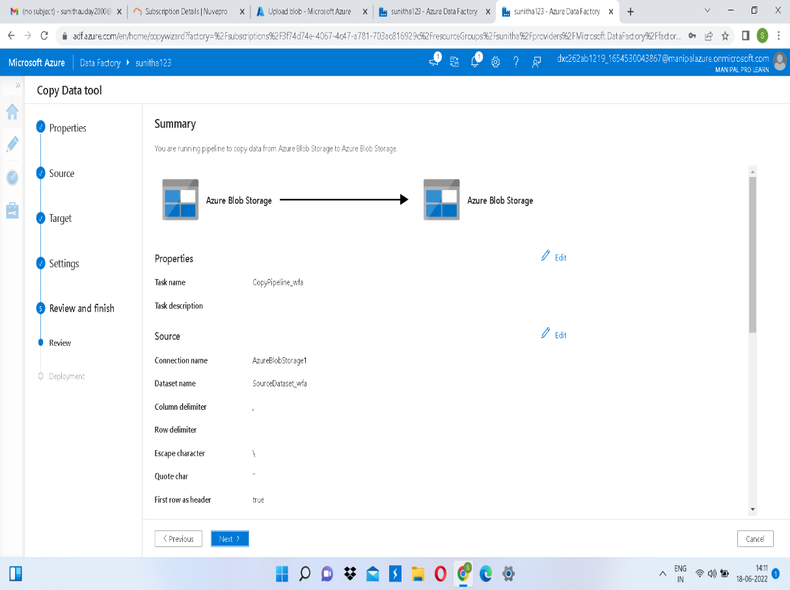

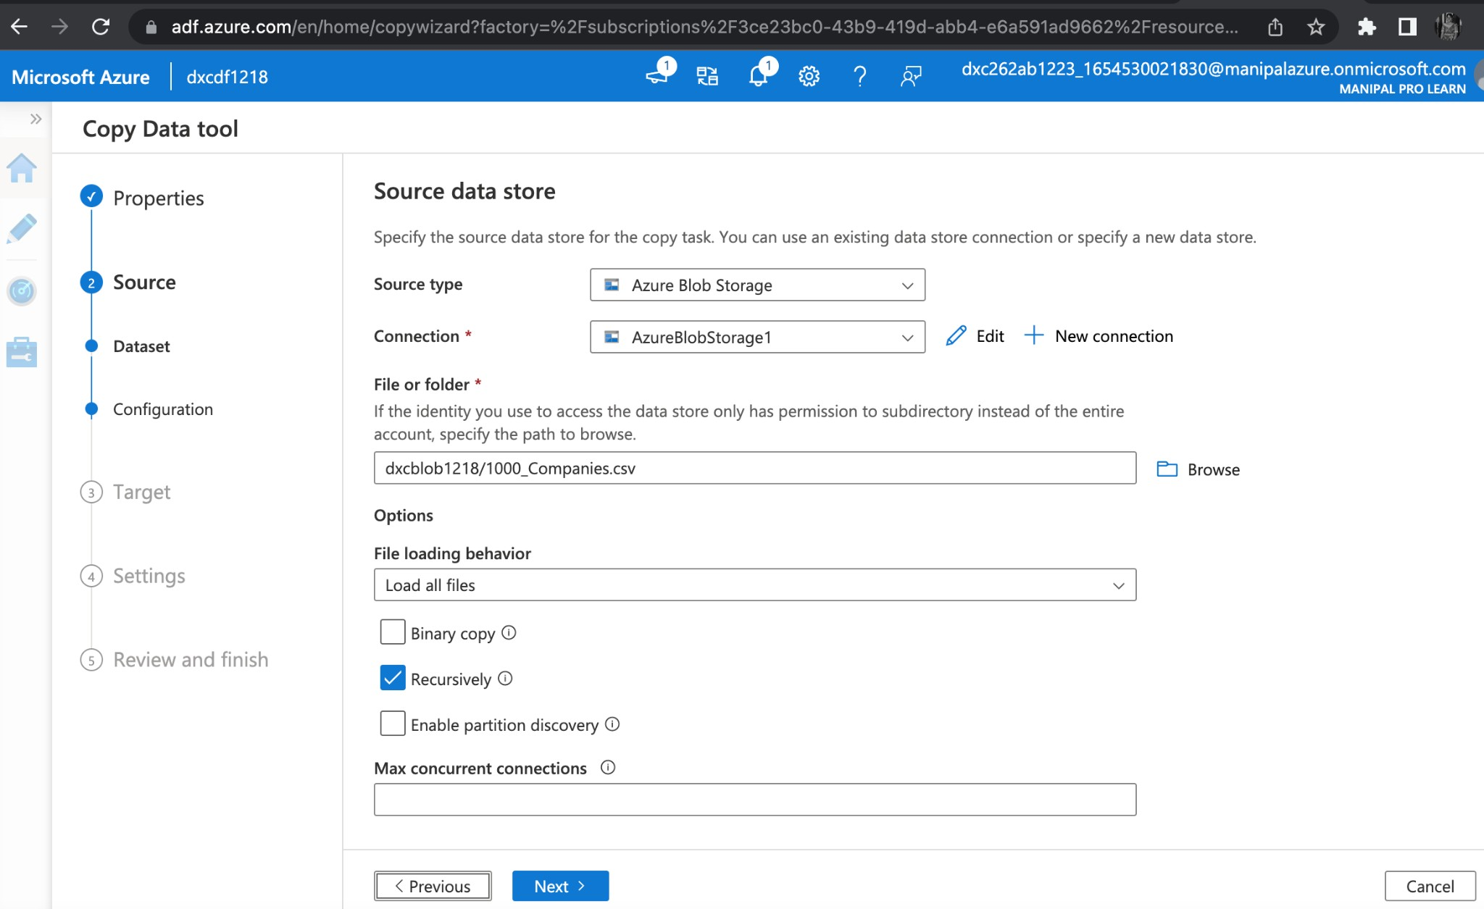

Step 12: Enabling pipeline trigger.

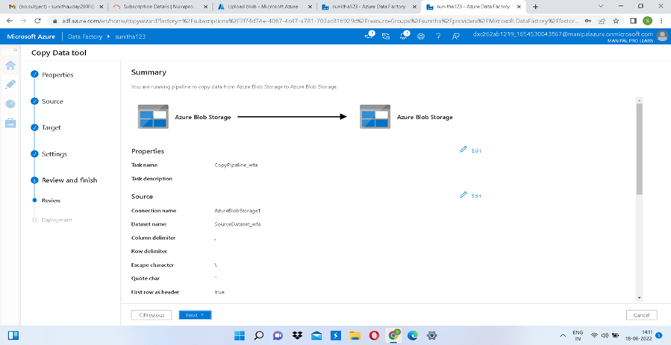

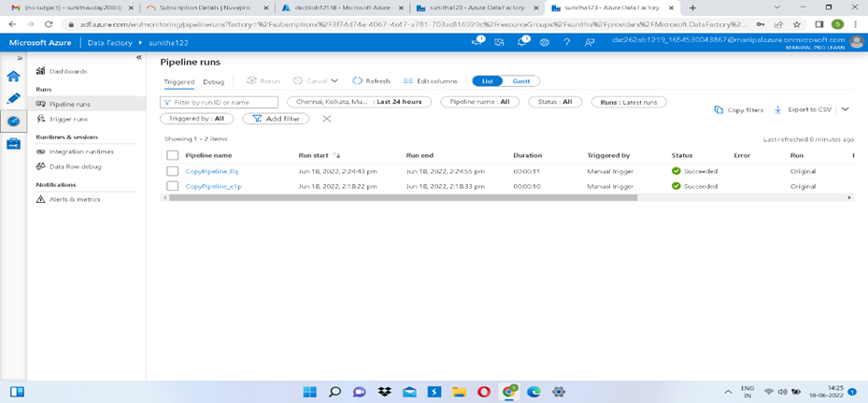

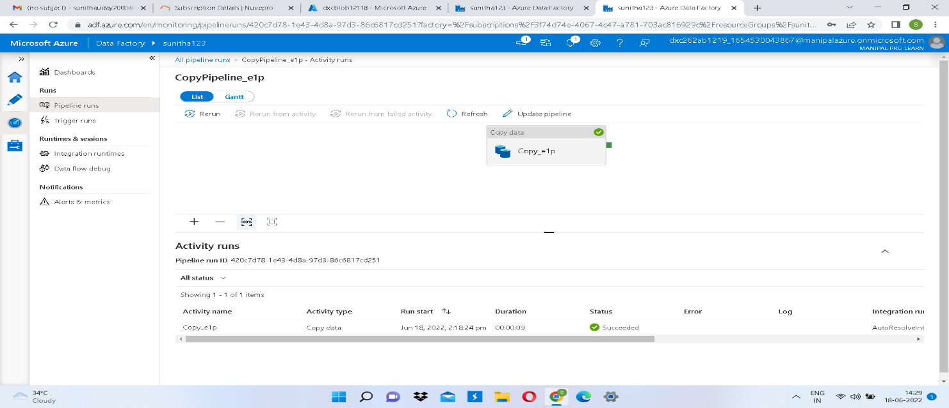

**Practical Lab:** Create **Azure blob trigger** logic

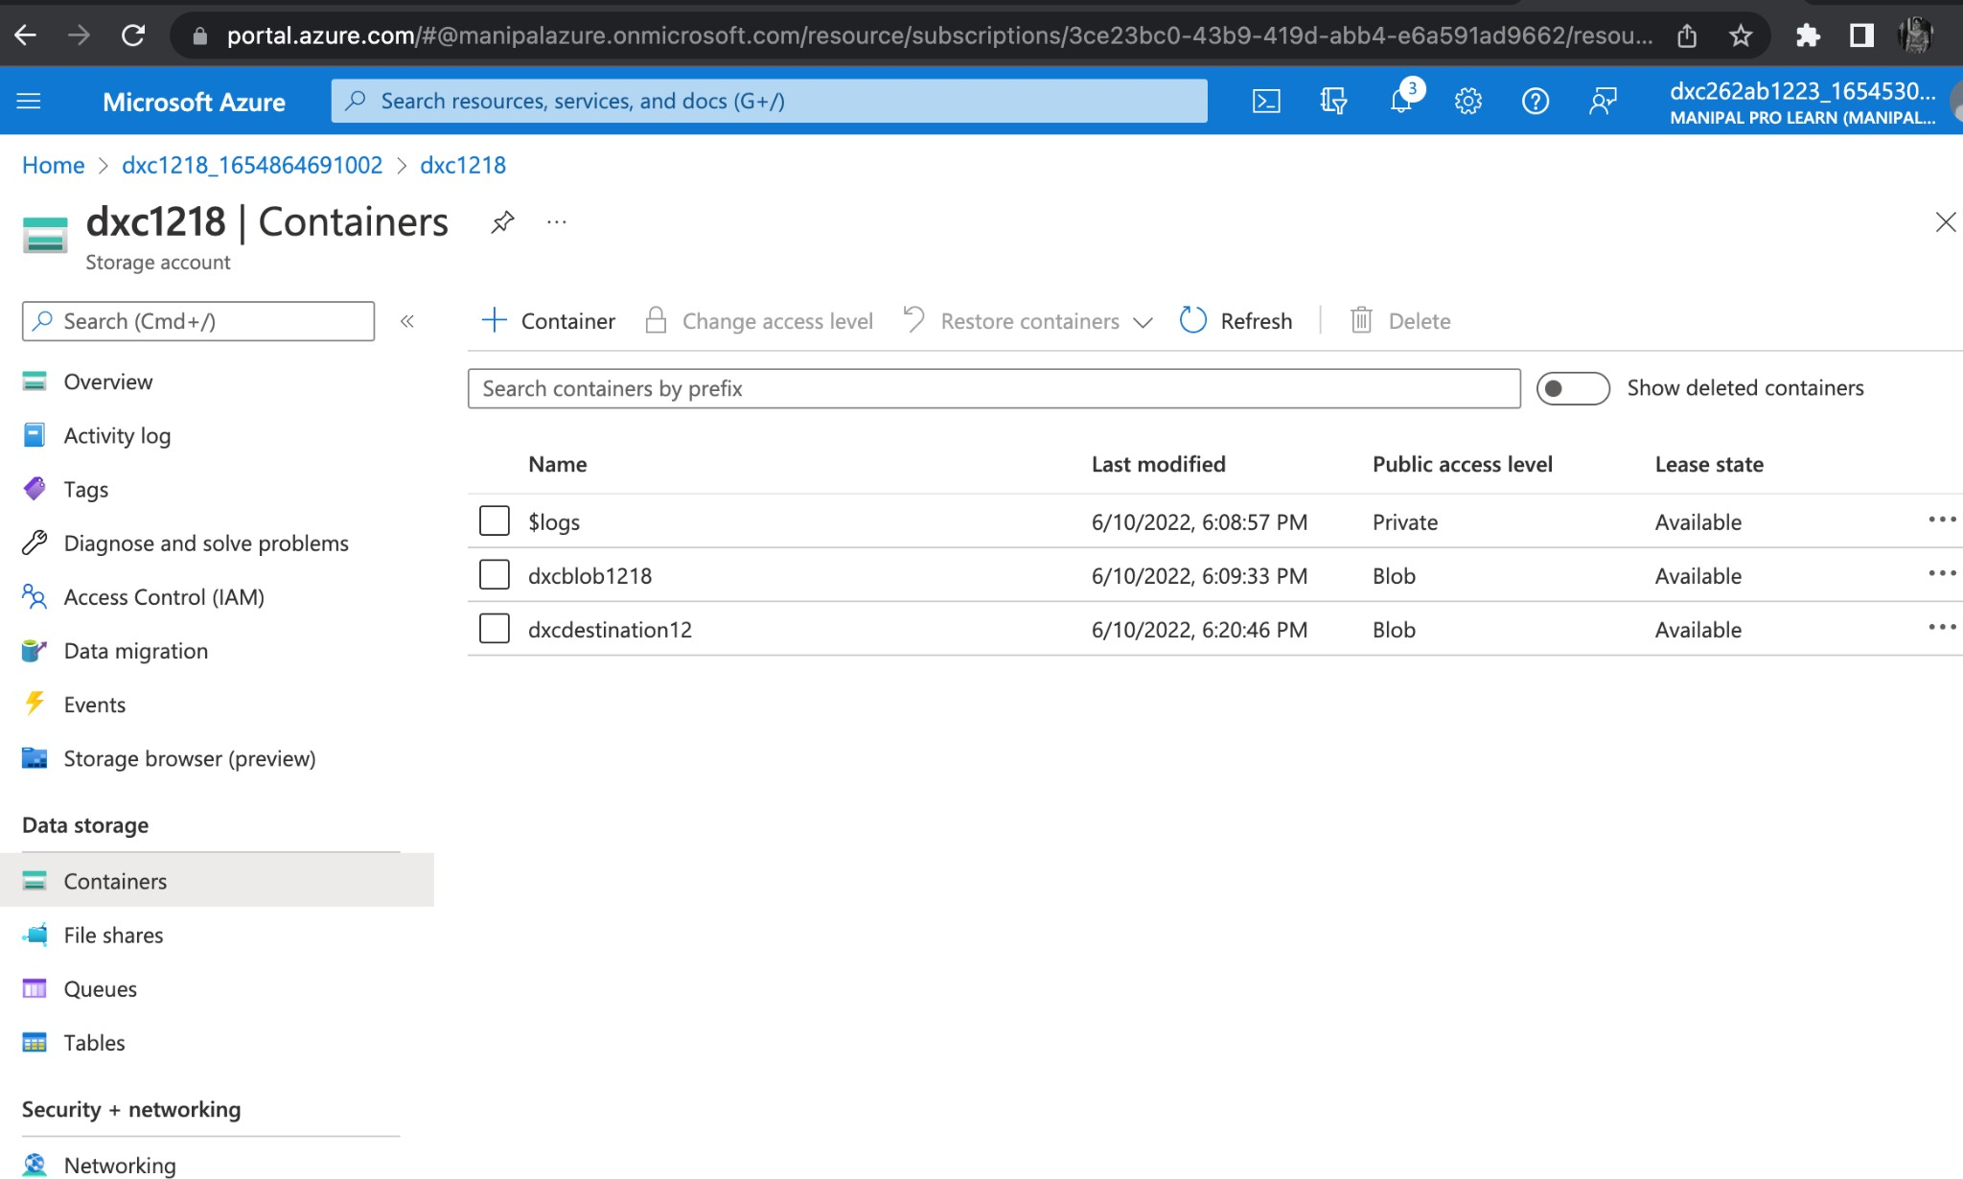**Step 1:** Create a Blob Storage Container as shown in the above steps.

**Step 2:** Enabling blob trigger.

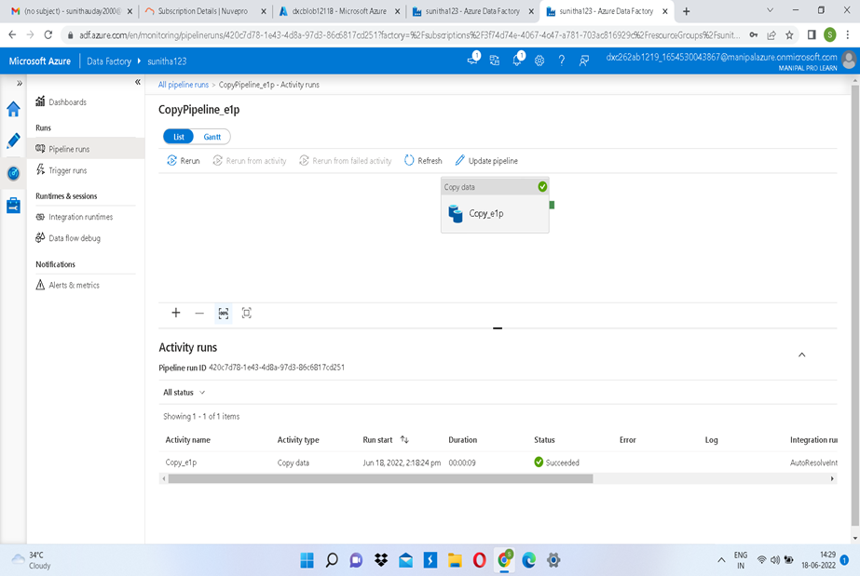

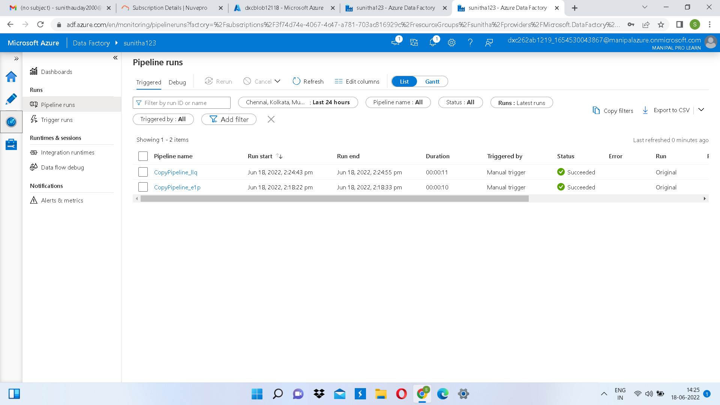

Practical Lab: Create Azure SQL Server and Database

CREATION OF SQL SERVER:

Step 1: Login to Azure portal and search for sql server.

Step 2: Open sql server and click on “ + create”.

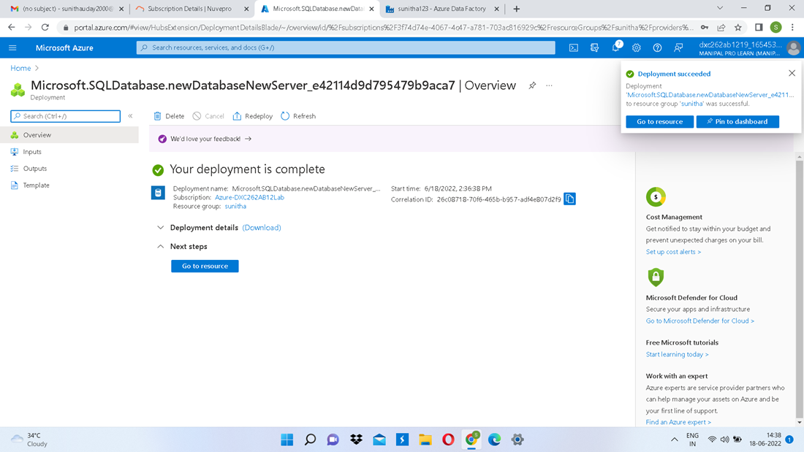

Step 3: Fill all the required fields.

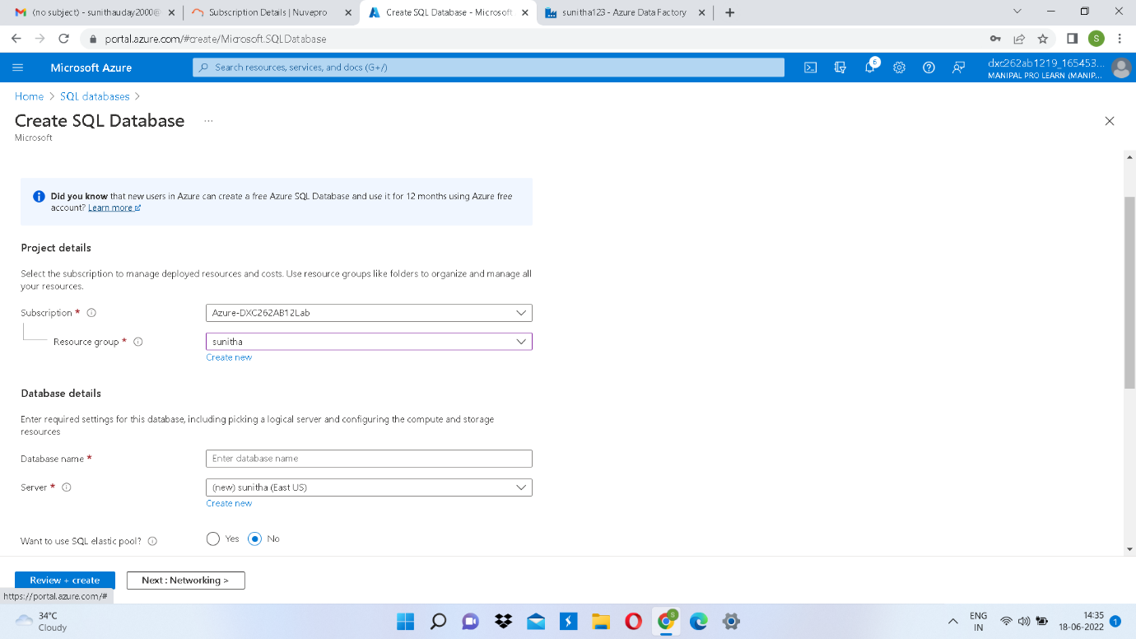

**Step 4:** Now click on “create” at the left bottom to start the deployment.

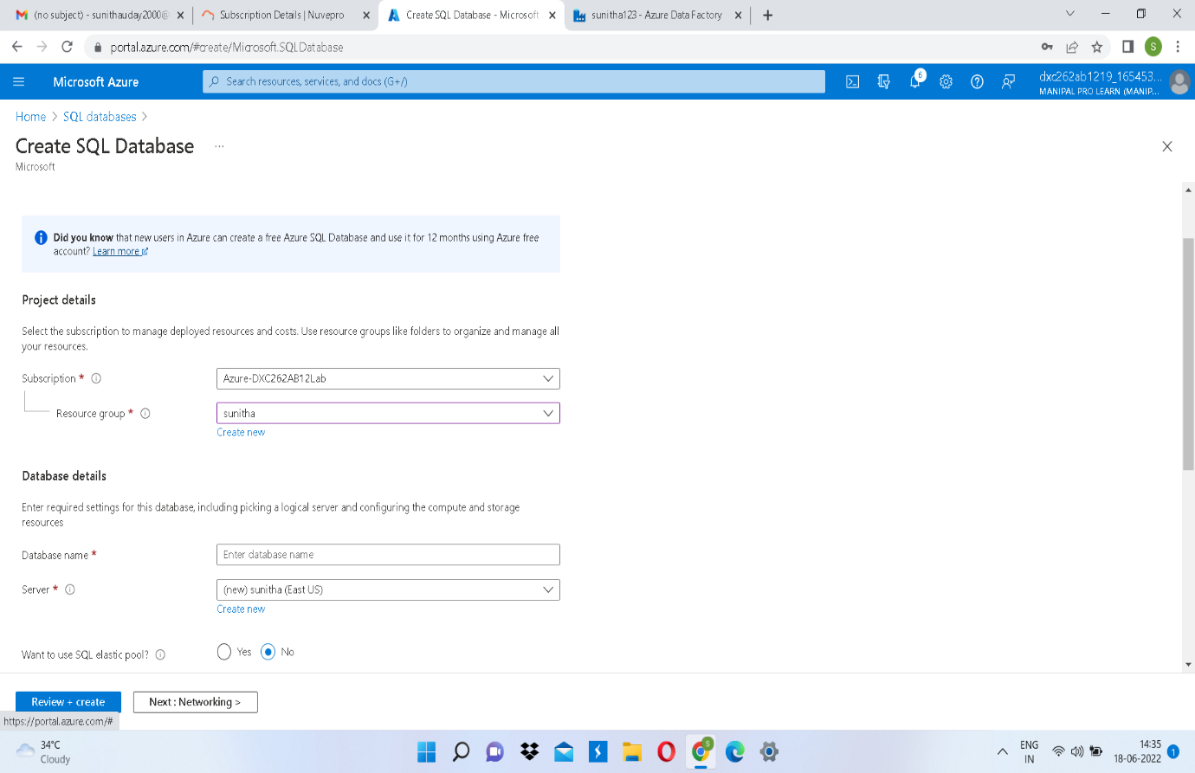

**Step 5:** Deployment completed.

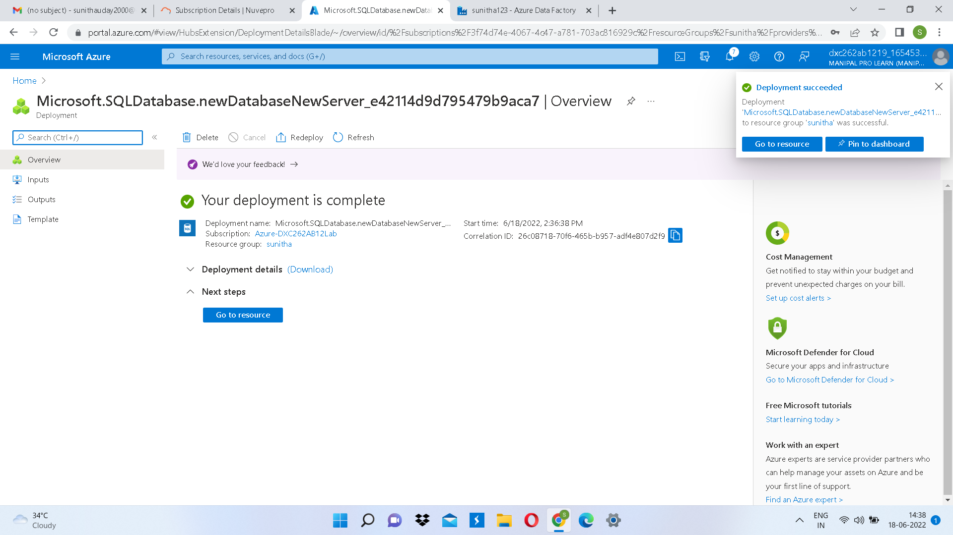

**Step 6:** Now create a sql database by clicking “+create database” in “Go to Resource”. 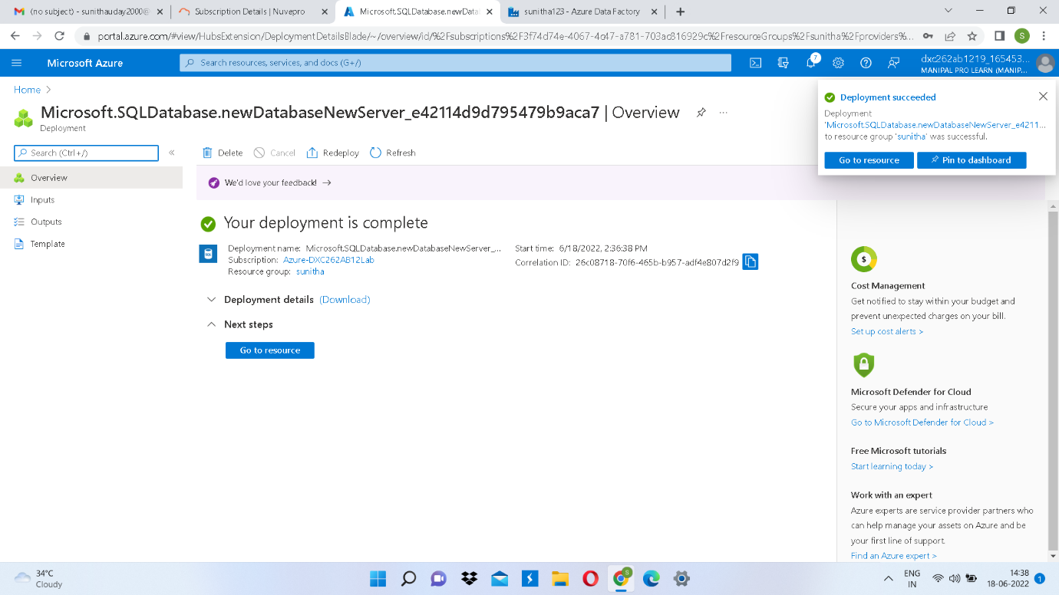

**Step 7:** Fill all the required fields that are needed to create a sql database.

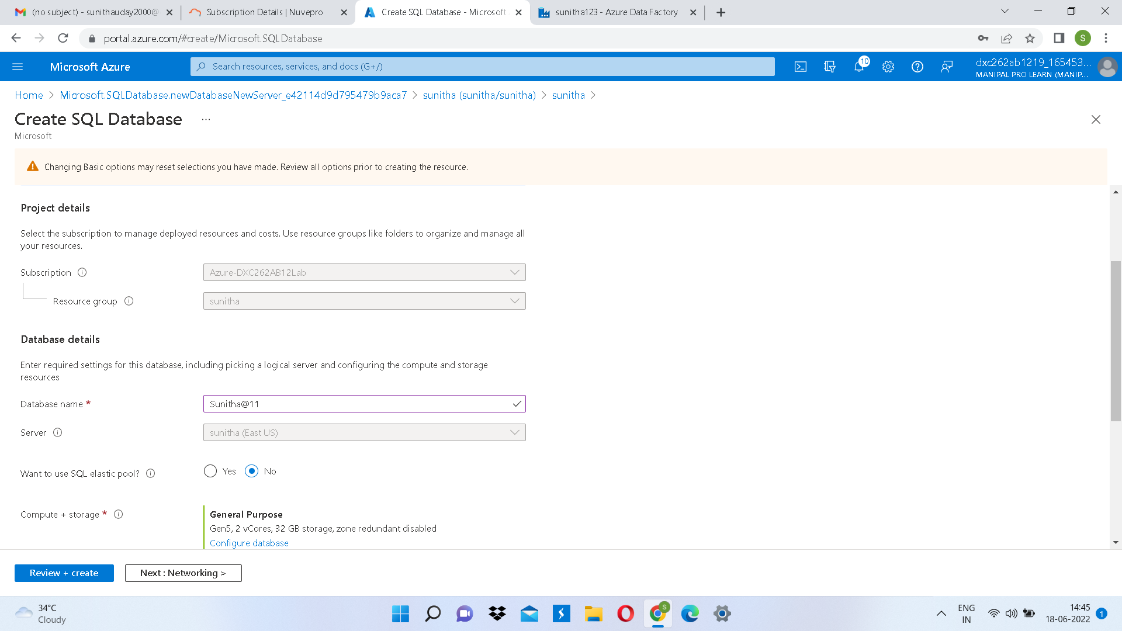

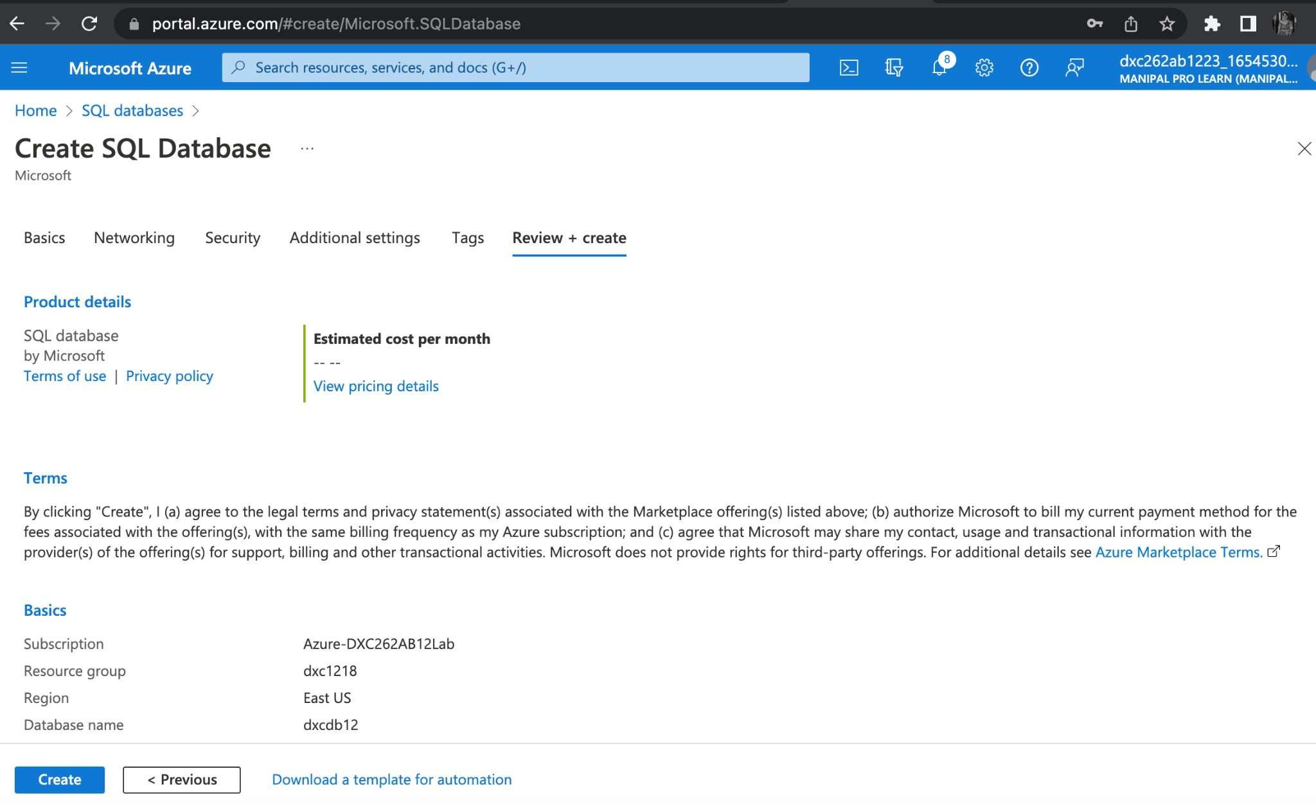**Step 8:** Click on Review+create to validate the details.

**Step 9:** Now click on create to deploy the database.

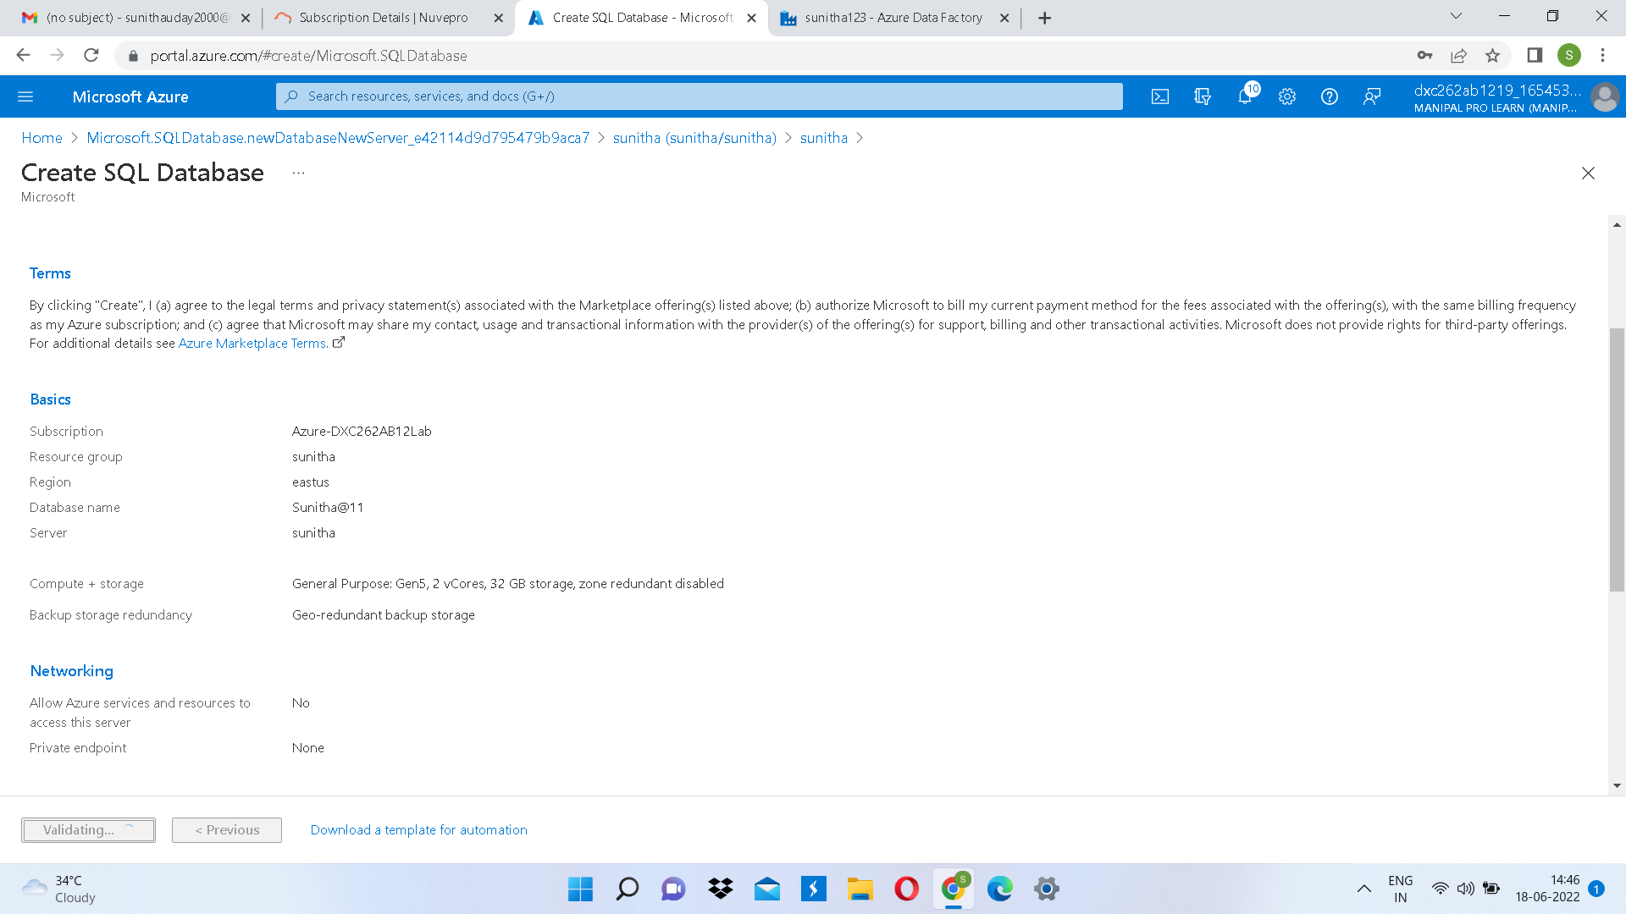

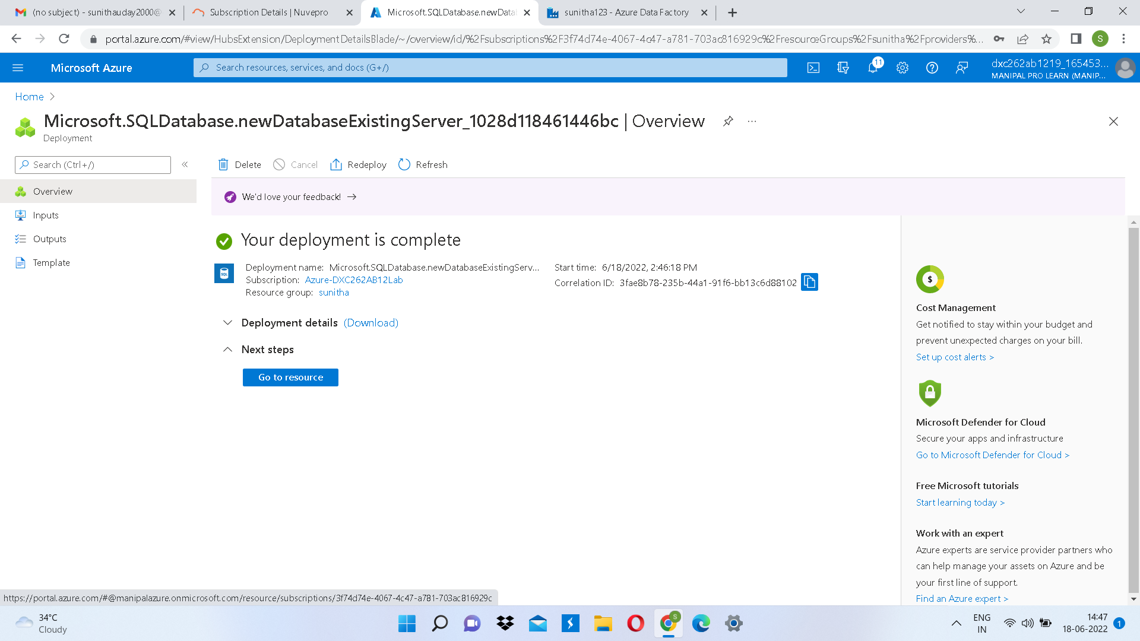

**Step 10:** Deployment completed.

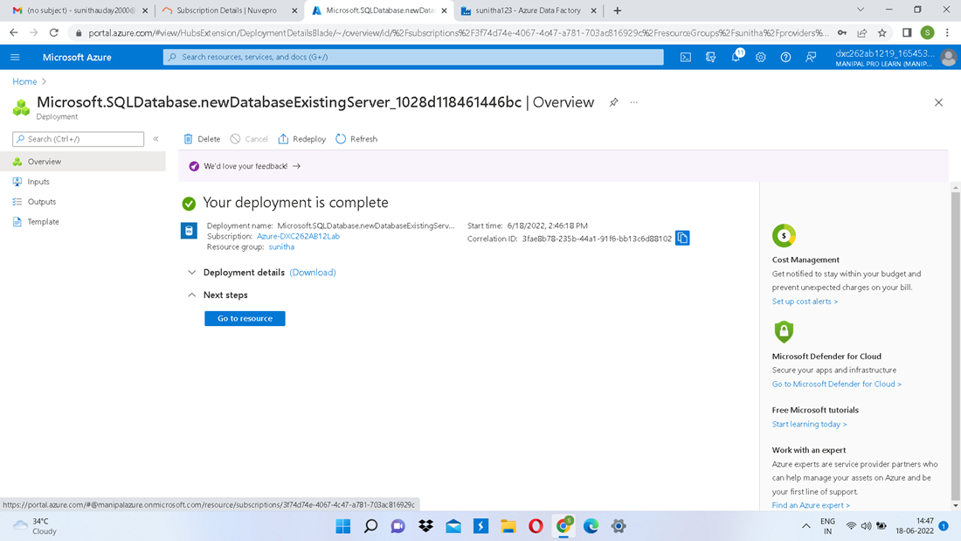

# SQL SERVER AND DATABASE CREATION IS COMPLETED.

**Practical Lab:** Add another pipelines for moving data from Staging to **SQL DB**

To solve this case we need to deploy a storage account, sql database and data factory as shown in the above steps.

Then we have to create a source container in the storage account to store the data.

To move the data to the SQL DB we need to use a pipeline. So create a pipeline in the data factory using a copy data tool.

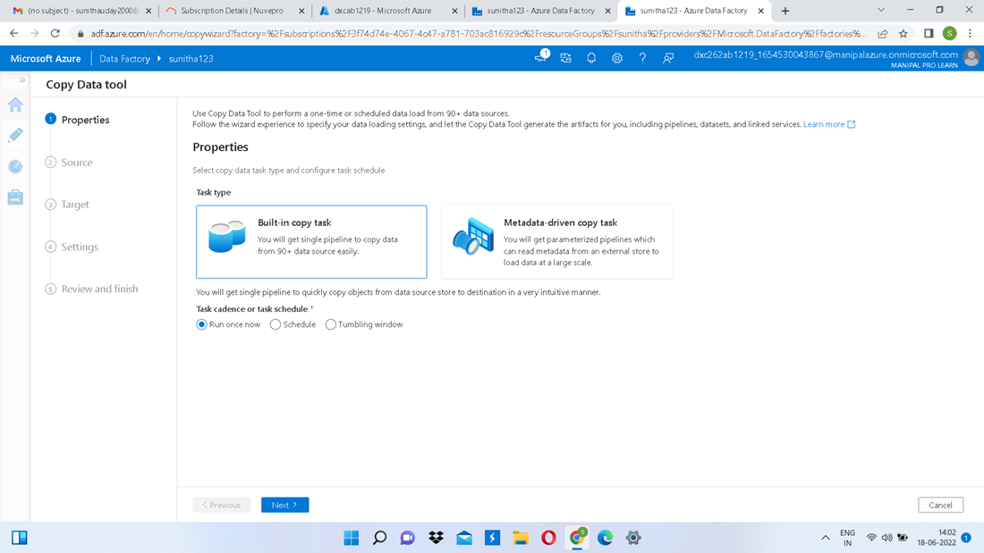

Fill all the required fields.

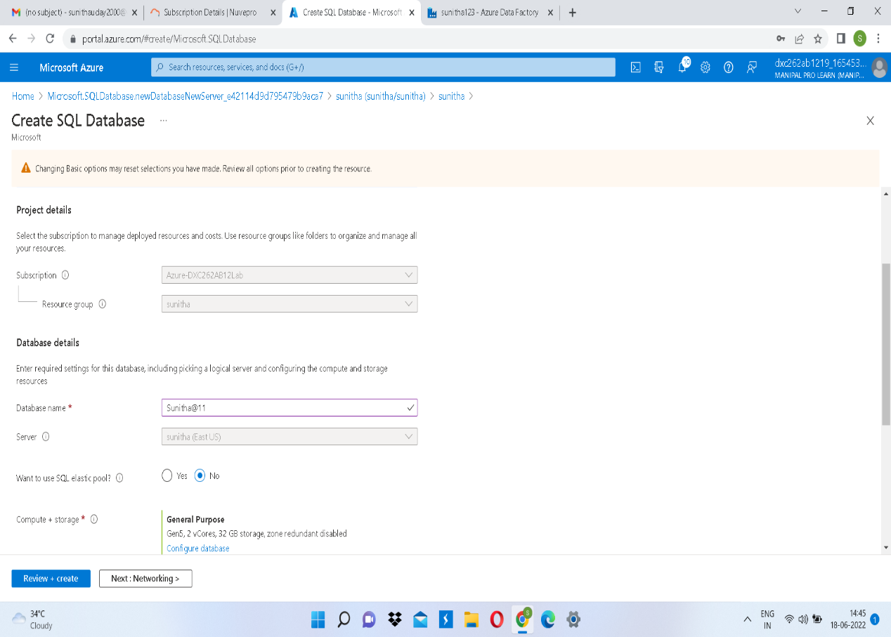

Select the target destination as SQL DB.

Check the summary and click on next to create a pipeline to move the data from blob to sql db.

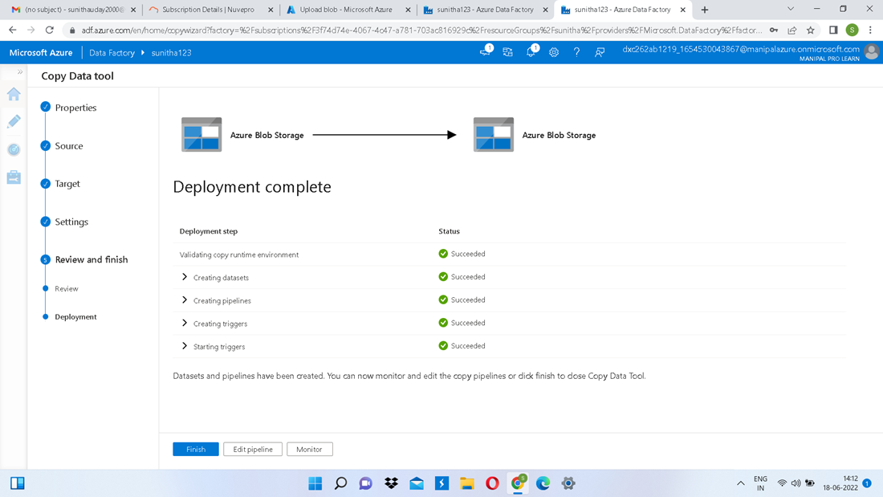

Pipeline has been created.

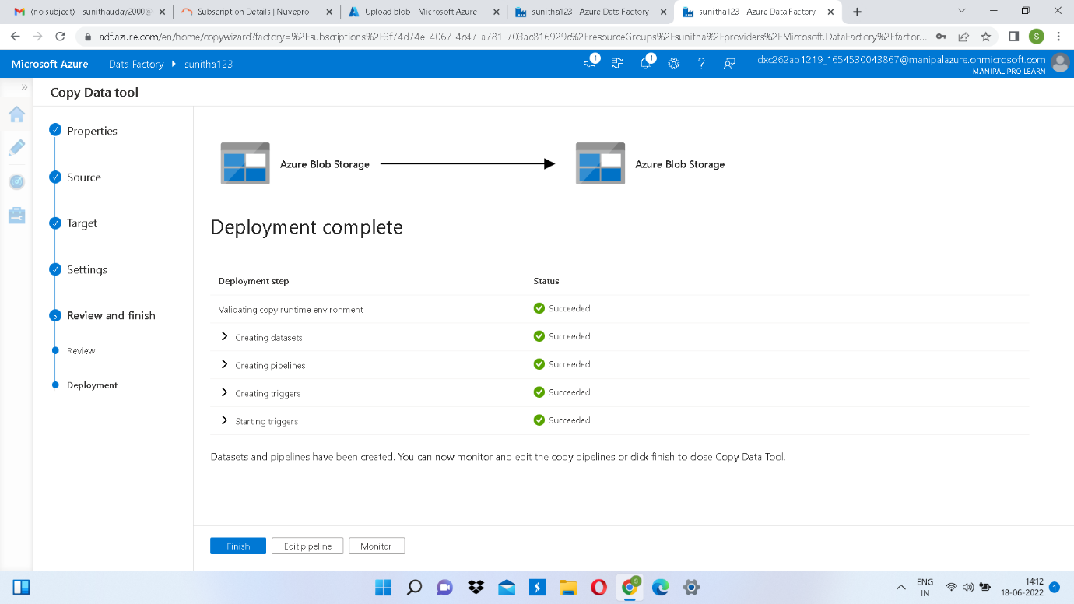

Now run the pipeline to move the data.

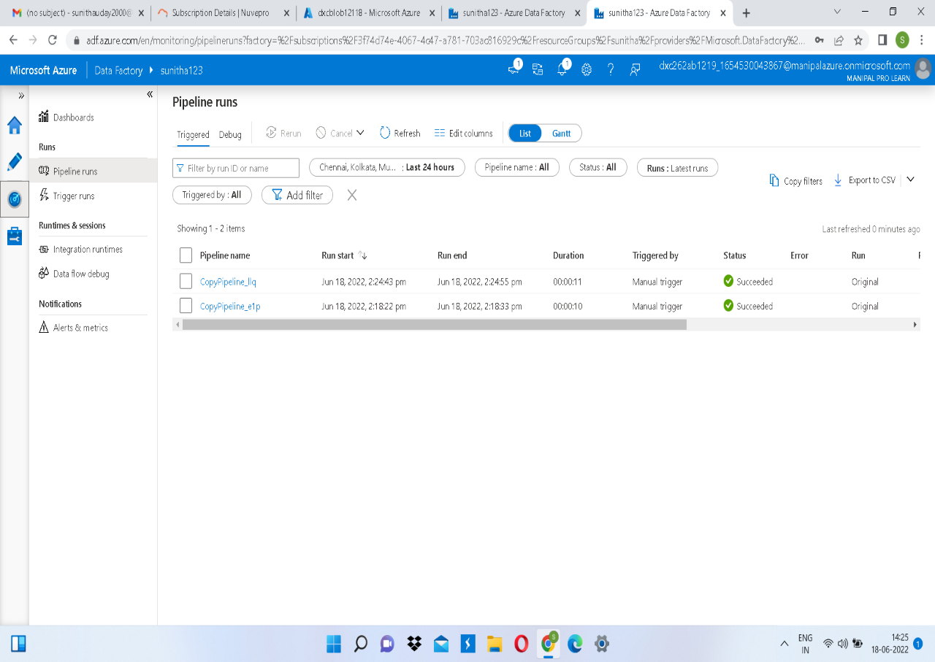

Now navigate towards the SQL database in order to check the data.

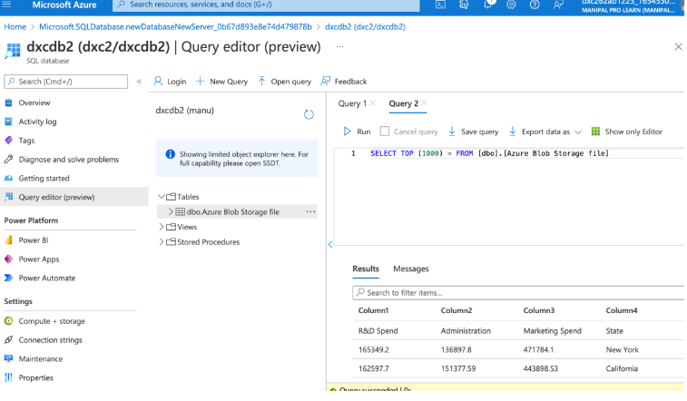

The data is successfully moved from storage account to SQL DB and can be accessed through querying.

**Result:** Using Azure Data Factory, we were able to create a pipeline that will validate and copy the blob data into the SQL database in this project.

**Conclusion:** The Blob data has been validated and put in the SQL database.